**Name: Bulbul Singh**

**Reg. no: 19BEC1243**

**Date: 04-10-2021**

**EXPERIMENT NO: 8**

**DESIGN OF PCB CIRCUIT USING EASY EDA VOLTAGE REGULATOR**

**Aim:** To design a voltage regulator and PCB circuit using EasyEDA tool and analyze its output waveform.

**Software used:** EasyEDA

**Circuit:**

**Voltage Regulator:**

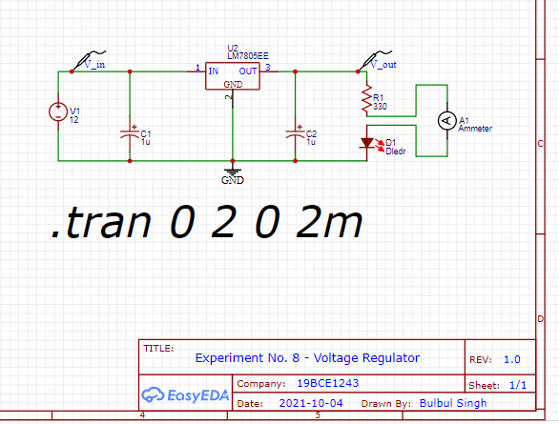

**Voltage Regulator circuit for PCB:**

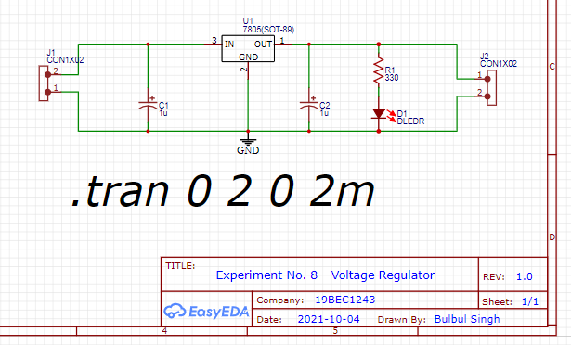

**Output Waveform:**

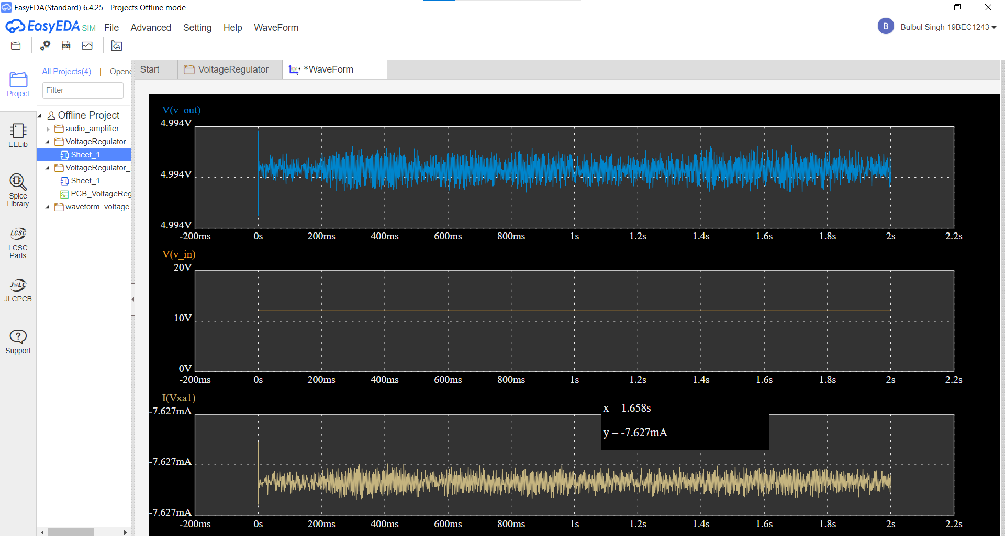

**PCB Circuit:**

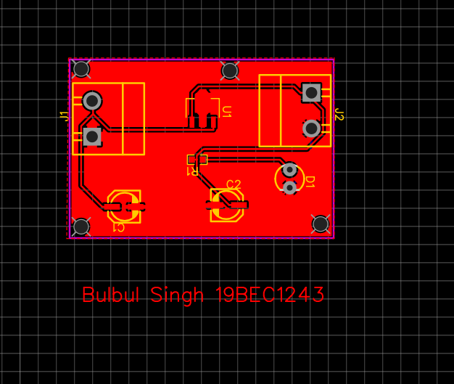

**Conclusion:**

From The output waveform of voltage regulator we can observe that when the input voltage is given as 12 v gives an output voltage 4.994 V which is approximately 5 V it means whatever may the current value the output will remain 5 V throughout.

In the PCB circuit of a voltage regulator J1 and J2 are the connectors, C1and C2 are the capacitors, R1 is the resistor, D1 is the led diode and U1 is the 7805-voltage regulator and the red color shows the cooper area usually referred as GND.

Thus, we successfully designed a voltage regulator and PCB circuit using EasyEDA tool and analyzed its output waveform.